Проверка На Факти: България НЯМА Най-Високата Ставка На ДДС Върху Хранителните Продукти В ЕС
Bulgaria Does NOT Have The Highest VAT Rate For Food Products In The EU
проверка_на_факти_българия_няма_най_високата_ставка_на_ддс_върху_хранителните_продукти_в_ес
Грешни данни
Is Bulgaria the country with the highest VAT rate for food products in the EU? No, that's not true: According to the latest updates in the European Commisssion Taxation and Customs database in 2023, Bulgaria's standard VAT rate is 20% but it goes down to 9% for food products suitable for babies or small children. On the other hand, other European countries such as Denmark and Lithuania have higher standard VAT rates and no reduced rates applied to food products.
The claim appeared in a TikTok video (archived here) published on August 27, 2023, showing data with reduced VAT rates on food products in selected countries, implying that Bulgaria has the highest VAT rate among EU countries. The comment, in Bulgarian language, reads:
Well done, we got the first place!
This is what the post looked like on TikTok at the time of writing:
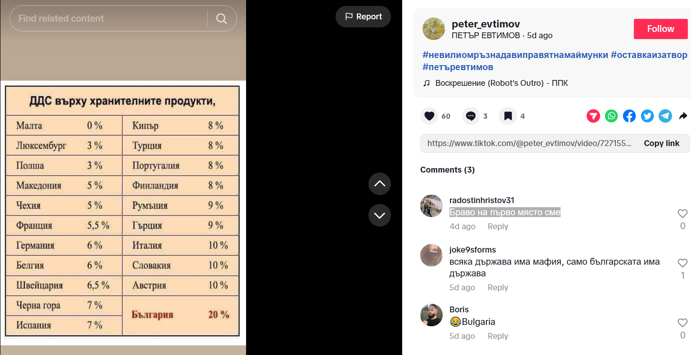
(Source: TikTok screenshot taken on Thu Aug 31 19:23:00 2023 UTC)
Other social media posts have been sharing the false claim that Bulgaria has the highest VAT rate for food products in the EU or worldwide:
Bulgaria is the only country in the EU with 20% VAT on food and the only one that does not support people in a crisis.
(Source: Facebook screenshot taken on Thu, Aug 31 19:44:05 2023 UTC)
(All translations from Bulgarian to English by Lead Stories staff).
Bulgaria follows the EU rules on VAT compliance; however, it is still free to set its own standard VAT rate, provided it is above 15%. There are various types of VAT rates that are applied in EU countries. The rate depends on the product or service involved in the transaction.
According to the European Union's official website, the VAT rates for food products may be applied differently in each EU country and for different type of food products. Some EU countries have a lower standard VAT rate for certain types of food products.
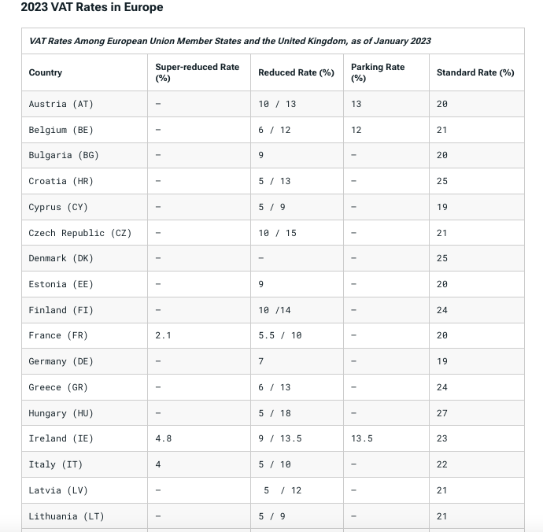
(Source: Taxfoundation.org. Screenshot taken on Tue, Sep 5 9:20:18 2023 UTC)
The European Commisssion Taxation and Customs database also shows, in the image below, that in 2023, Bulgaria's standard VAT rate is 20%. A reduced 9% rate, though, is applied to foods suitable for babies or small children.
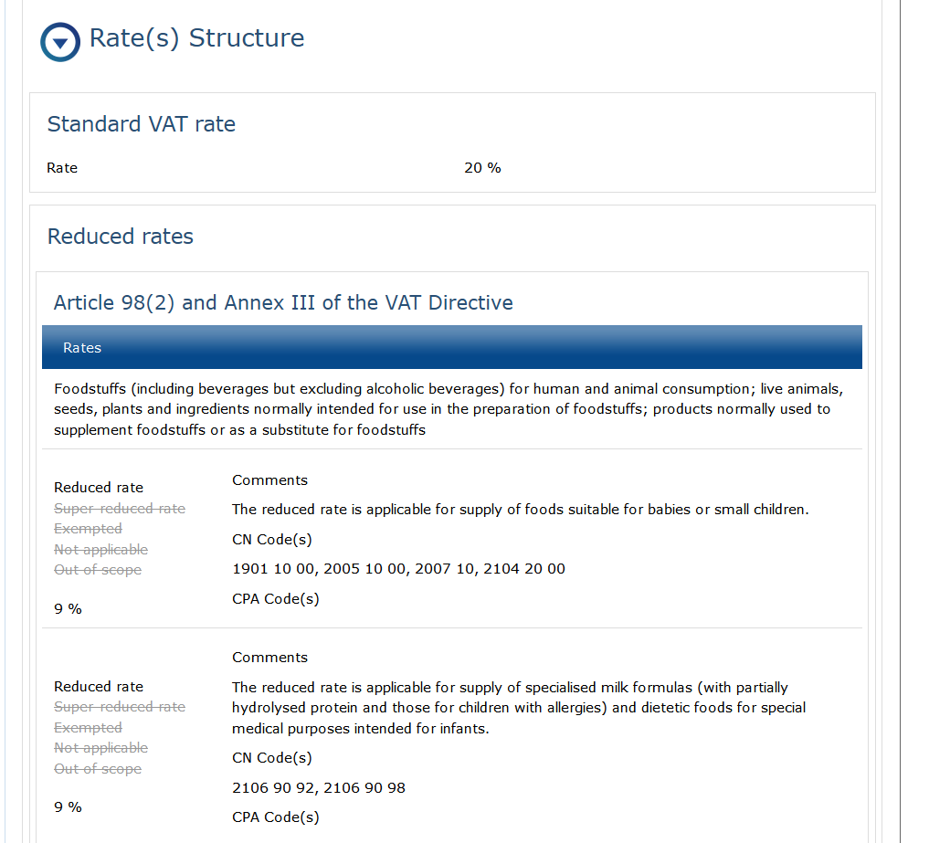
(Source: European Commission Taxation and Customs Database updated on July 10, 2023. Screenshot taken on Fri, Sept 1 19:05:02 2023 UTC)
In comparison, Estonia has the same standard VAT rate as Bulgaria, with no reduced rates for general food products, though a 9% reduced VAT rate is applied only to pharmaceutical products; and Denmark and Lithuania have higher standard VAT rates and no reduced rates for food products (including beverages but excluding alcoholic beverages) for human and animal consumption:
- Estonia (20% standard VAT, no reduced rates for general food products)
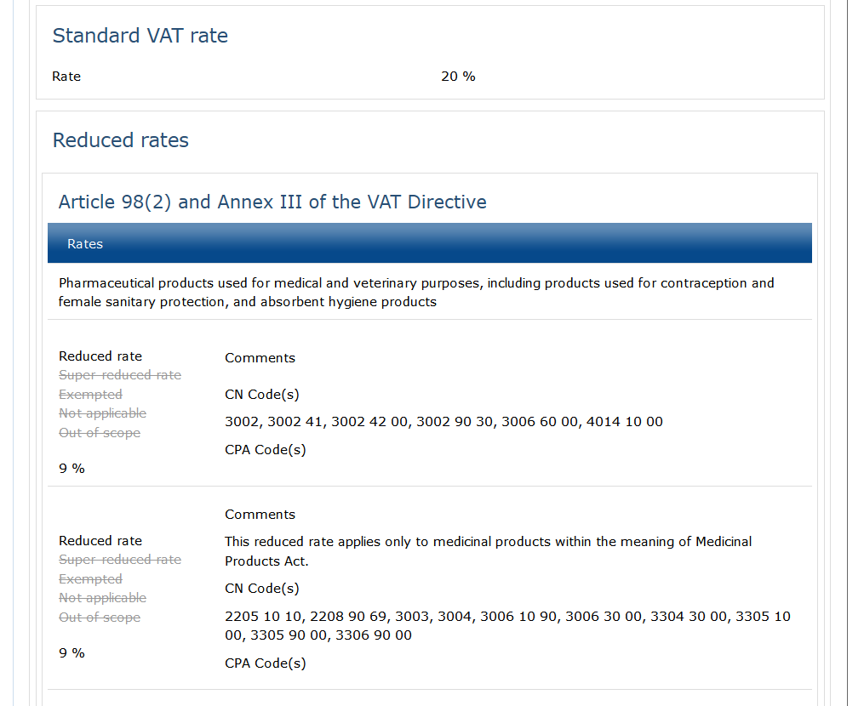
(Source: European Commission Taxation and Customs Database updated on June 26, 2023. Screenshot taken on Mon, Sept 4 18:37:35 2023 UTC)
- Lithuania (21% standard VAT, no reduced rates for general food products)
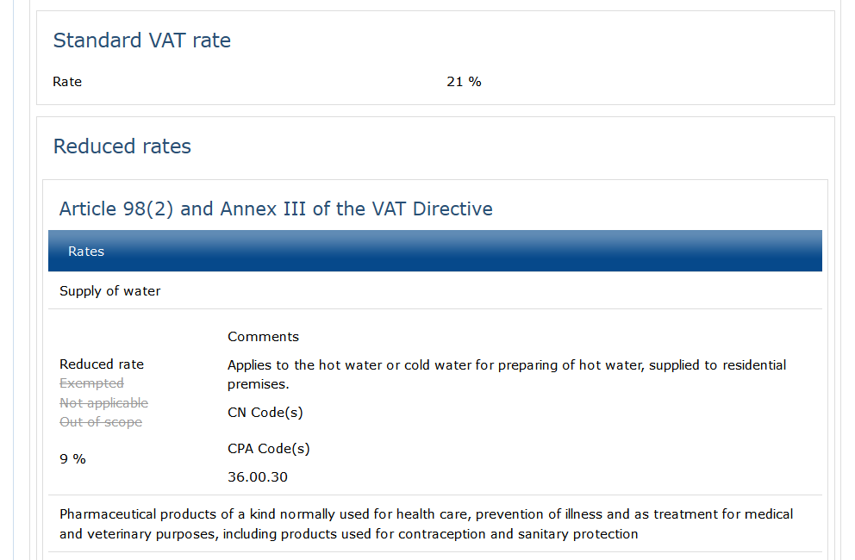
(Source: European Commission Taxation and Customs Database updated on July 7, 2023. Screenshot taken on Mon, Sept 4 18:39:04 2023 UTC)
- Denmark (25% standard VAT, no reduced rates for general food products)
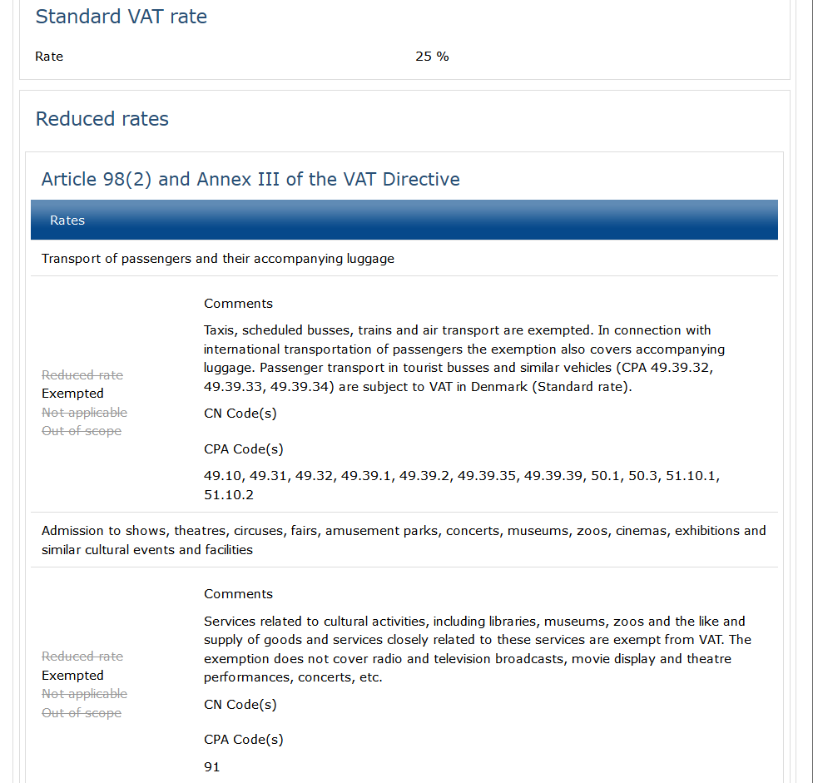
(Source: European Commission Taxation and Customs Database updated on February 23, 2023. Screenshot taken on Mon, Sept 4 18:41:03 2023 UTC)

